**Smart Ambulance**

**Mnar salah ashry**

**Merna mourad Khalil**

**Alaa Mohamed abdelreheem**

**Shaimaa atef abd elaziz**

**Problem Definition:**

**Ambulance services help many people with serious or life threatening conditions. They also provide a range of other urgent and planned health care and transport services. But the manual ambulance system is not giving this service.**

* **Road traffic has become the major challenge in current cities, which made inconvenient for an ambulance if it is carrying an emergency patient. The ambulance must wait for clearing the traffic, which may take several minutes to hours sometimes. Due to this ambulance reaches the hospital with many delays, and there may be a condition that patient undergoes hazardous problems or may die. But in this system can solve this problem.**
* **The system also monitors the patient health present in the ambulance and the doctor can make a report on the patient's condition and help him with the devices equipped inside the ambulance.**
* **Saving time for the doctor inside the hospital in diagnosing the patient's condition, as the patient information or data store in the database.**

**Feasibility Study**

**We have determined after studying the system the required Software and Hardware resources needed to create the system while maintaining a reasonable budget and efficiency.**

**The Software in use Were (Net Beans IDE) used to connect between database and backend functions,(Visual Paradigm and Draw.io) Which was used to create some of the required UMLs during the study of the system,(My SQL) used to build our database connections and (Windows 10 O.S) Was Used to host all these Software Programs.**

**Hardware we worked on was a laptop of 4GM RAM, Processor i_5gen8 and 10 GB free disk space for software and logs, this Laptop was used to host and act as database server during the development of the system.**

**Functional Requirements**

1. **Nurses and doctors can query medical history of patient.**
2. **Nurses can make query on supplies for each case and know the available supplies in hospital.**
3. **Nurses can record medical measurements for each patient.**
4. **Doctor can add any surgery data for any patient.**
5. **Nurses can query on nearest hospital location to the patient's location.**
6. **Nurses and doctor can access and login to the system**
7. **Patient can Send Request the ambulance on the system.**

**Nonfunctional Requirements**

1. **Performance**

* **Our proposed system shall provide 24 hours accesses for the users.**
* **The proposed system runs on any kind of operating system.**
* **After the user send request the response time is fast.**

1. **User Interface**
2. **Security and Access Permission**

* **Our system is secured; means unauthorized body cannot access the system and system resources.**
* **The system shall permit the Doctors to edit user's information.**

1. **Usability**
2. **Availability**

* **Ambulance System is available every time For User.**

1. **Supportability**

* **The ambulance system should be supportable in the current equipment such as computers, monitors and smart mobile phone.**

**Use Case Description**

|  |  |
| --- | --- |
| **Use case name** | **Medical history query** |
| **Use case number** | **Mh-1** |
| **description** | **Nurses and doctors can make queries of patient’s medical history** |
| **actors** | **Doctor - patient** |
| **Pre-conditions** | **Patient has documented history** |
| **Sequence of events** | **Doctor will login to the system then Searching by patient ssn then he get the wanted data** |
| **Post-conditions** | **System will be ready to another query** |
| **exceptions** | **Invalid SSN, no medical history** |

|  |  |
| --- | --- |
| **Use case name** | **Case supplies** |
| **Use case number** | **Cs-2** |
| **description** | **Searching for the hospitals containing the suitable supplies for each case** |
| **actors** | **Ambulance doctor, patient case ,** |
| **Pre-conditions** | **Ambulance request,** |
| **Sequence of events** | **Search using case category then get the needed supplies and the hospitals with these supplies** |
| **Post-conditions** |  |
| **exceptions** | **No documented supplies for this case** |

|  |  |
| --- | --- |
| **Use case name** | **measurements Recording** |
| **Use case number** | **Mr-3** |
| **description** | **Recording medical measurements for the patient** |
| **actors** | **Doctor, patient** |
| **Pre-conditions** | **Patient is in ambulance ,** |
| **Sequence of events** | **Doctor login , Assigning patient data , assigning medical measurements** |
| **Post-conditions** | **Measurements is documented** |
| **exceptions** |  |

|  |  |
| --- | --- |
| **Use case name** | **Adding surgery** |
| **Use case number** | **Ad-4** |
| **description** | **Doctor can add any surgery data for any patient** |
| **actors** | **Doctor, patient** |
| **Pre-conditions** | **Valid Doctor login, valid patient SSN** |
| **Sequence of events** | **Doctor login, entering patient data , assigning surgery data** |
| **Post-conditions** |  |
| **exceptions** | **Invalid doctor login, invalid patient SSN** |

|  |  |
| --- | --- |
| **Use case name** | **Nearest hospital** |
| **Use case number** | **Nh-5** |
| **description** | **Doctor can query for nearest hospital location to the patient location** |
| **actors** | **Doctor,** |
| **Pre-conditions** | **Valid Current location, ambulance request** |
| **Sequence of events** | **Doctor login , searching for nearest hospital, document desired hospital address** |
| **Post-conditions** |  |
| **exceptions** | **invalid login,** |

|  |  |
| --- | --- |
| **Use case name** | **Doctor login** |
| **Use case number** | **dl-6** |
| **description** | **Doctor can login by his name and SSN** |
| **actors** | **Doctor , system** |
| **Pre-conditions** | **Valid doctor SSN** |
| **Sequence of events** | **Doctor login , system check that login, home page are shown** |
| **­** | **Doctor could access on the system** |
| **exceptions** | **Invalid login** |

|  |  |
| --- | --- |
| **Use case name** | **Ambulance request** |
| **Use case number** | **Ar-7** |
| **description** | **Patient can enter his case data and current location to request an ambulance** |
| **actors** | **Patient, system** |
| **Pre-conditions** | **Send current location** |
| **Sequence of events** | **Patient entering his data, his case category and his location** |
| **Post-conditions** | **That data are saved, for doctors use,** **The system knows patient request and patient get ambulance service** |
| **exceptions** | **Invalid data** |

**Use Case Diagram**

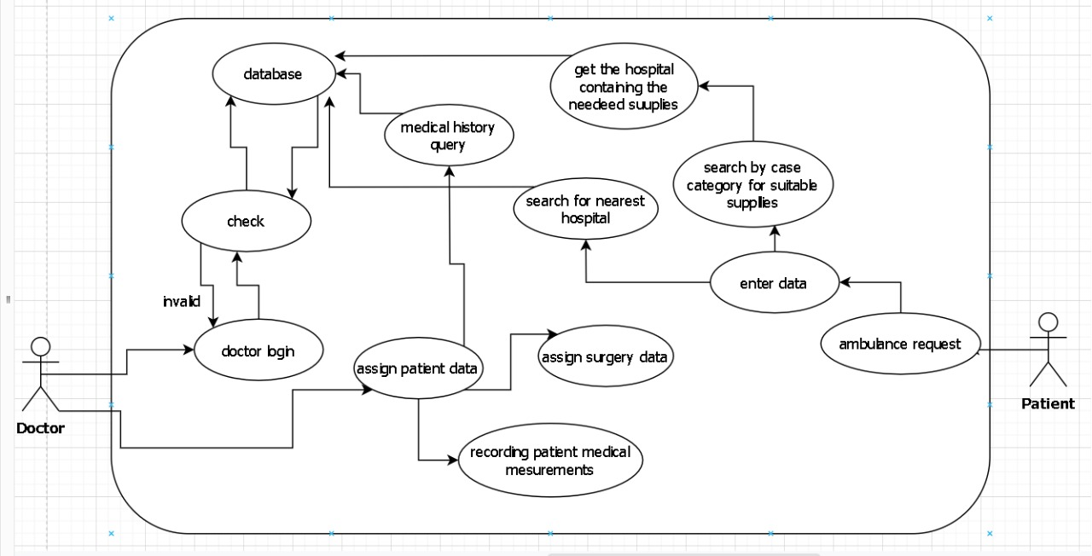

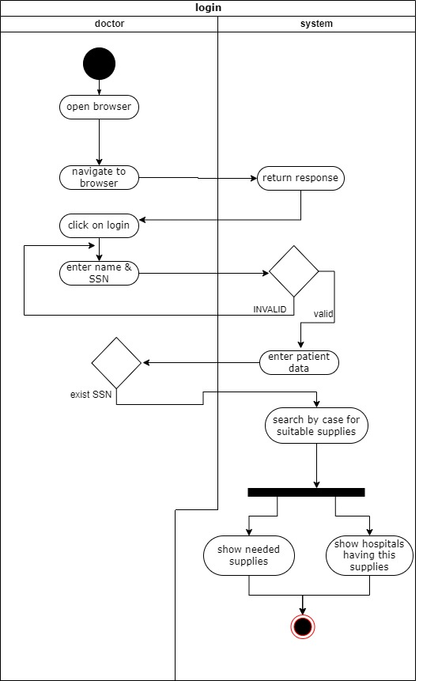**Activity Diagram**

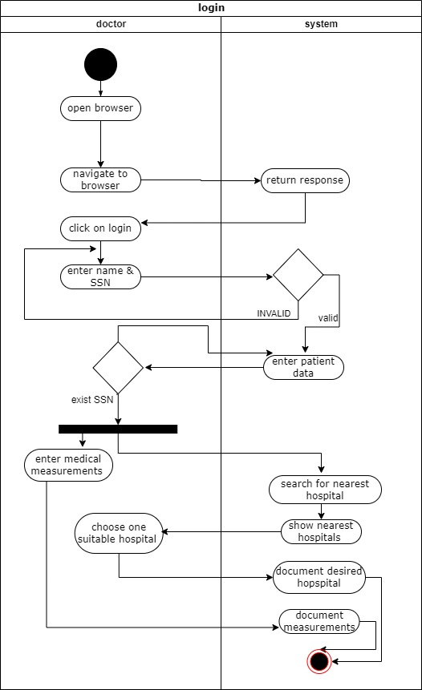

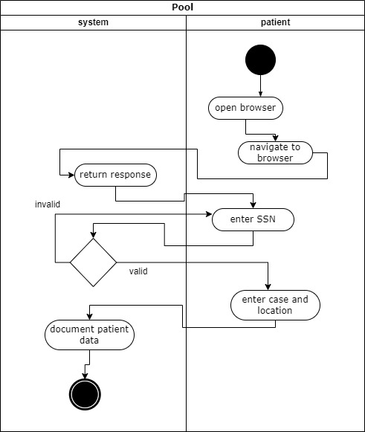

**Sequence Diagram**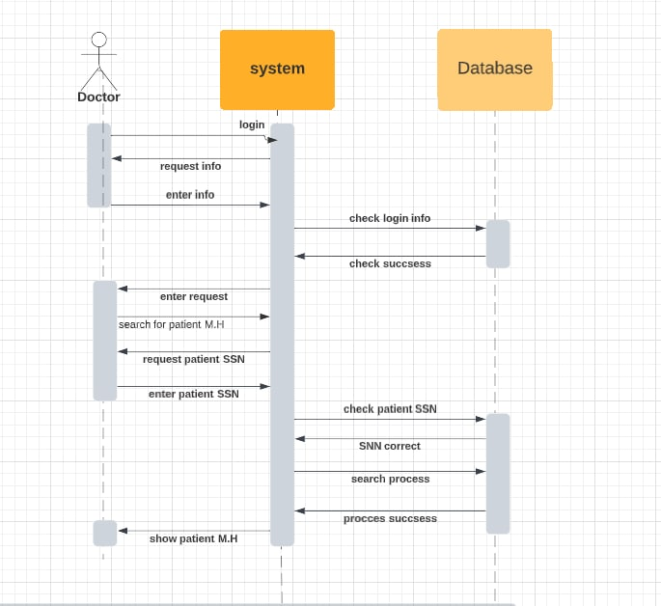

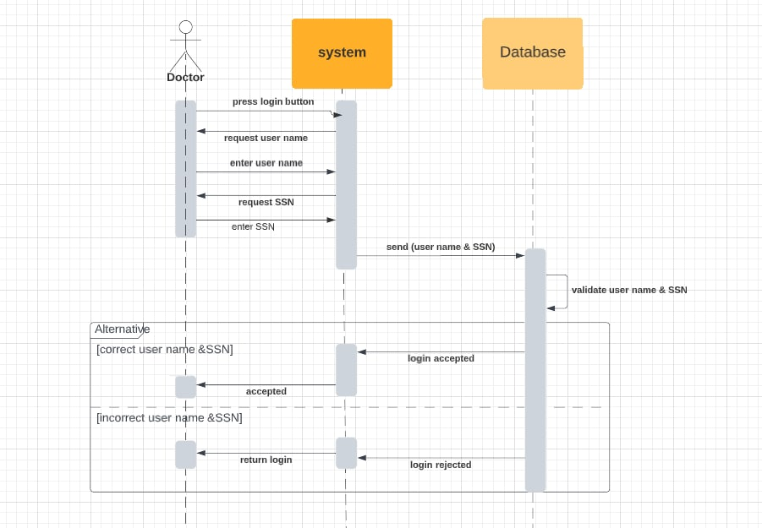

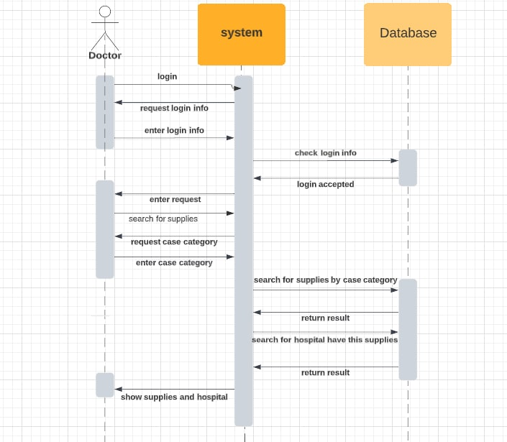

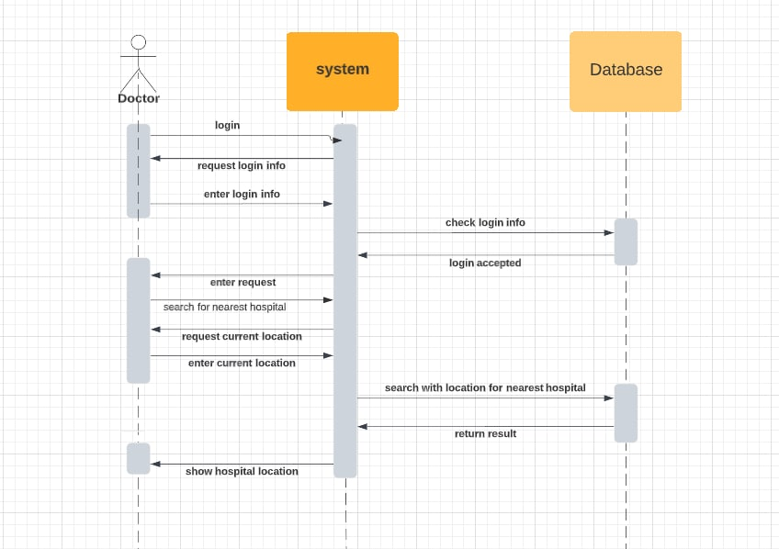

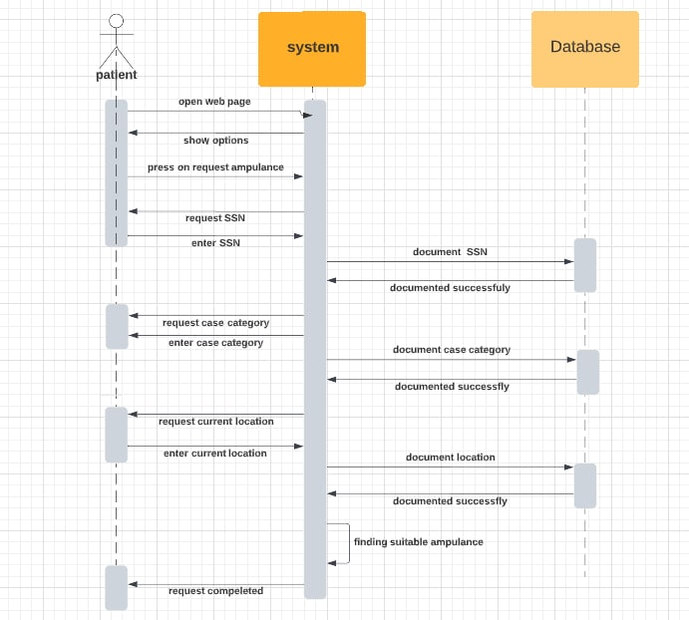

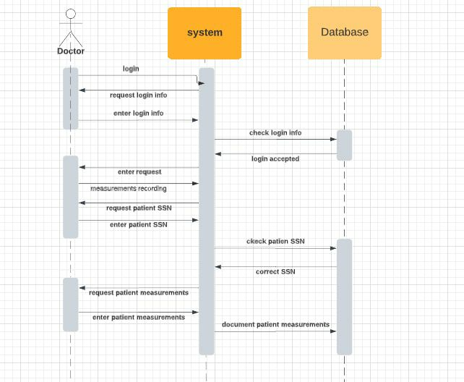

**ERD**

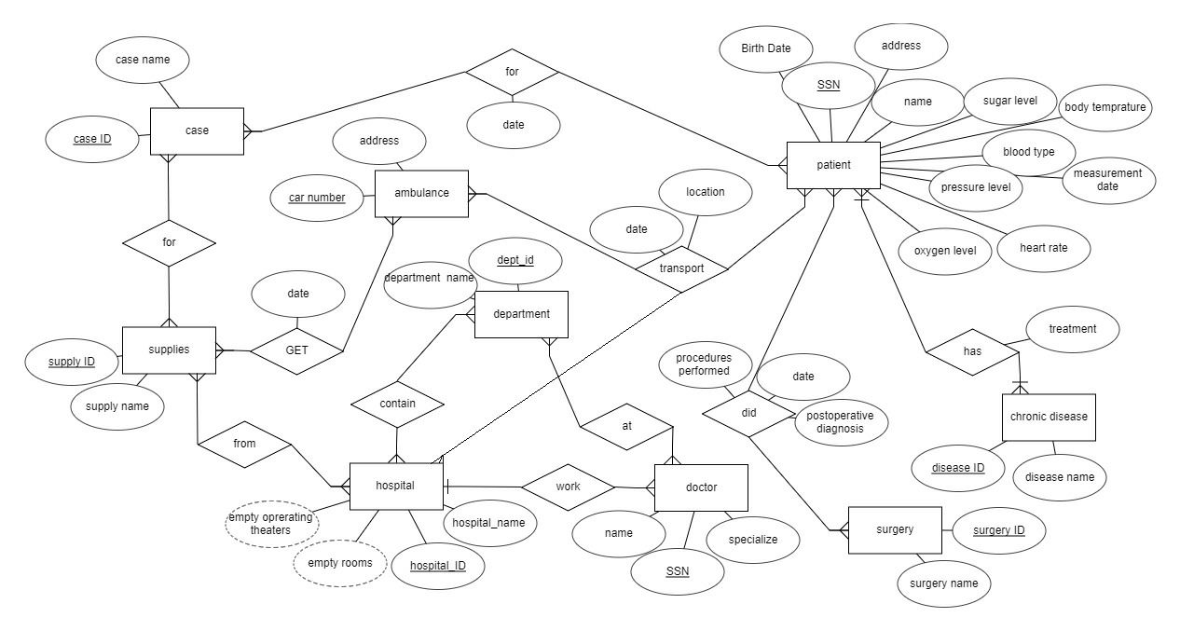

**Schema**

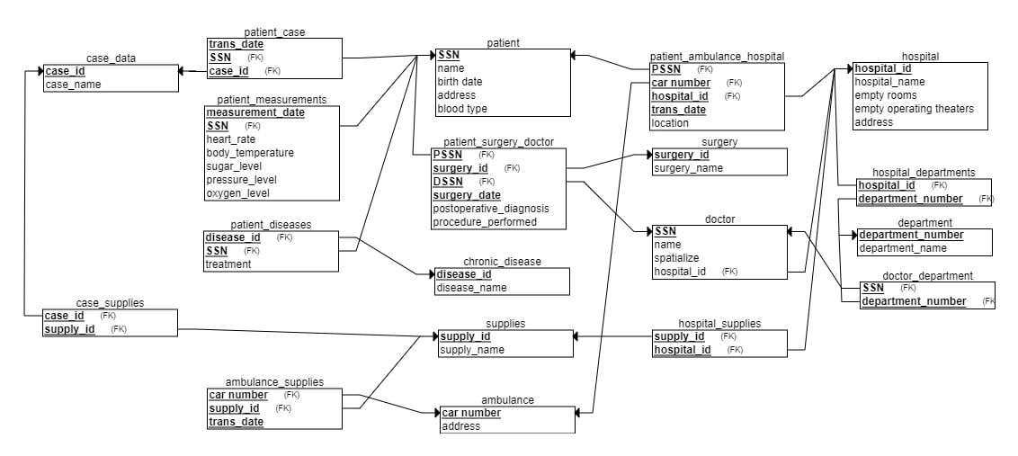

Class diagram

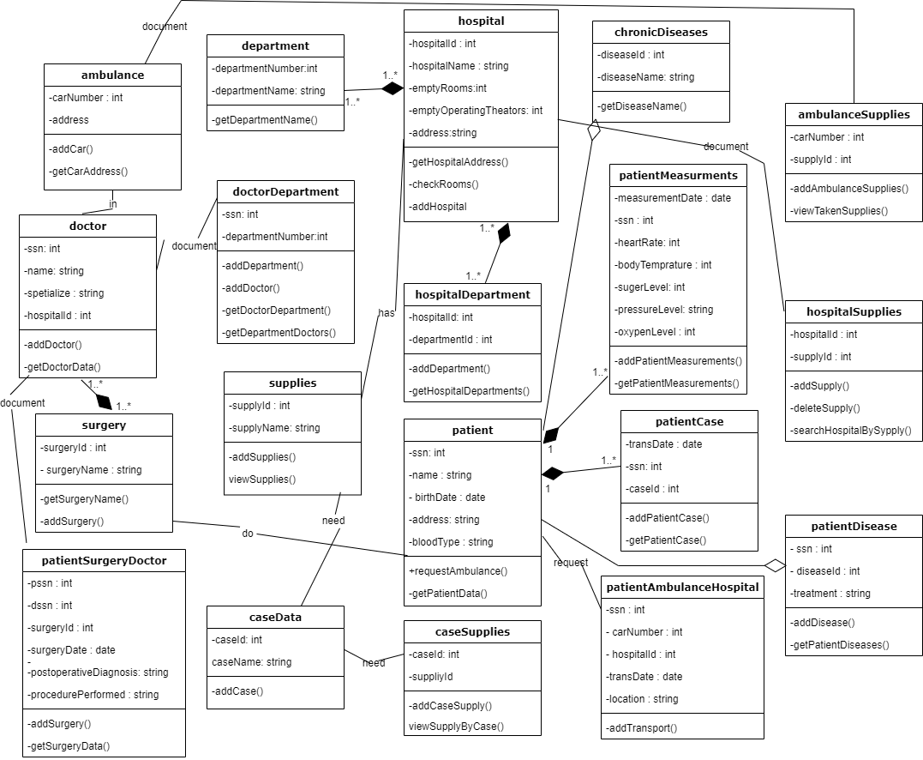

Component diagram

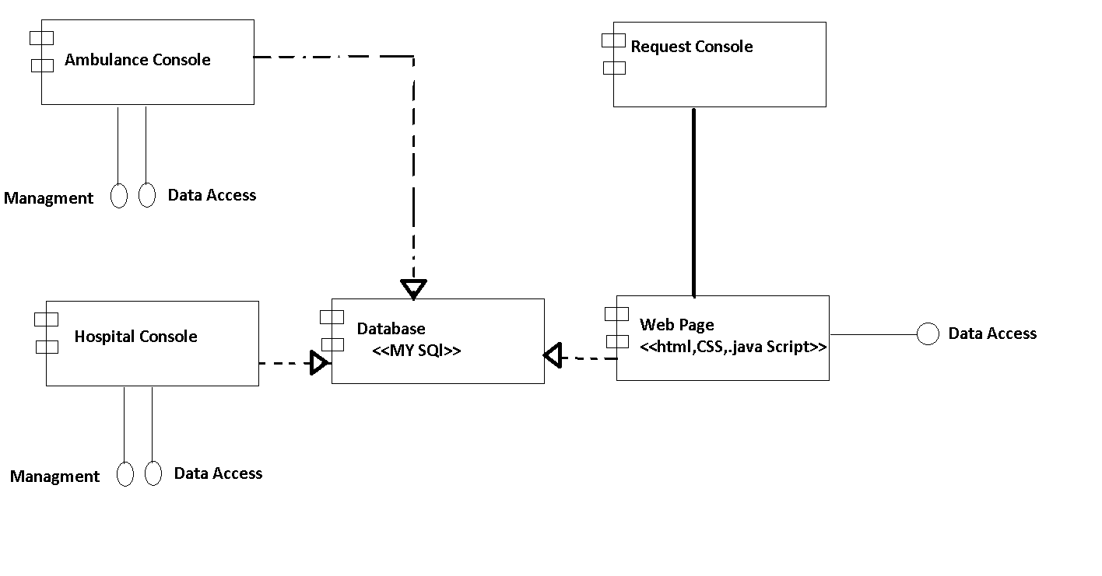

Deployment diagram

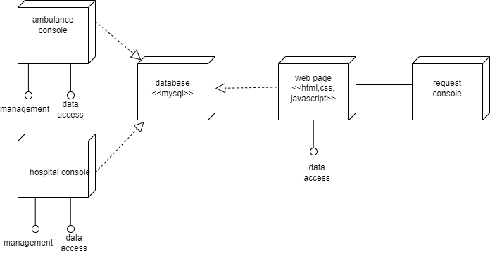

collaporation diagram

